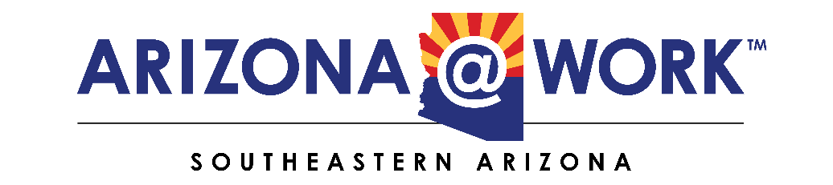

NOTICE AND AGENDA OF PUBLIC MEETING OF THE
SOUTHEASTERN ARIZONA WORKFORCE DEVELOPMENT BOARD (WDB)

Pursuant to A.R.S. § 38.431.02, notice is hereby given to the members of the Southeastern Arizona WDB and to
the general public that the Southeastern WDB will hold a regular meeting open to the public on:

Thursday, December 18, 2025
10:00 AM
Cochise College – Downtown Center
2600 E. Wilcox Drive, Room A102
Sierra Vista, Arizona 85635

Join In-Person or Zoom Meeting
https://zoom.us/j/2048227879?pwd=NG51ZTgrK29wRkVkRWN6UXF1UzgwUT09
Meeting ID: 204 822 7879
Passcode: 1Tzf0K

AGENDA

- Call to Order - Ron Curtis

- Roll Call - Lori Baron

“If such a conflict does arise, I will declare that conflict before the board and
refrain from discussing and voting on matters in which I have conflict.”

- Call to the Public -Ron Curtis
This is an opportunity for public comment. Unless the comment relates to agenda
items, Board action is limited to directing staff to study and/or schedule the matter
for future consideration. Members of the Board may also respond to criticism. The
Board Chair will impose a three (3) minute time limit on each person's comments
and a fifteen (15) minute overall time limit on public comments in general.

- Action Item: To Approve/Disapprove December 18, 2025 Agenda - Ron Curtis

- Action Item: To Approve/Disapprove September 18, 2025 Minutes - Ron Curtis

- Earn to Learn Presentation - Kate Hoffman
Adam Begody

- Fee for Service -Vickie Simmons

- Discuss 2026 Retreat & Appoint Retreat Committee - Ron Curtis

- Financial Report: Budget and Expenditures - Wick Lewis

- One-Stop Operator Report - Jim Mize

- Core Partner Reports:
One-Stop Employment & Training Reports - Vickie Simmons
Rehabilitation Services Performance Report - Elizabeth Kinder
Employment Services Performance Report - Teresa Celestine
Adult Education Performance Report - Cochise - Cara Elkins

- Executive Director’s Report - Vada Phelps

- President’s Report - Ron Curtis

Board Announcements

Next Meeting: Thursday, March 19 @ 10:00 a.m.

Benson, Arizona

Adjourn

ARIZONA@WORK is an Equal Opportunity employer/program.
Funded by WIOA federal dollars serving Adults, Youth, and Dislocated workers

