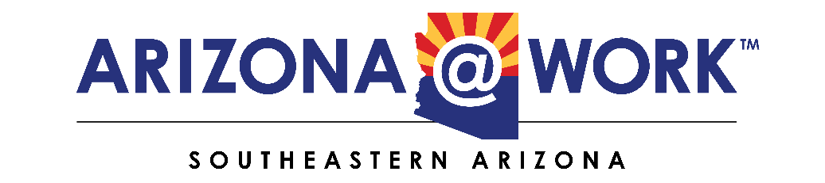

900 Carmelita Dr. Sierra Vista, AZ 85635
Executive Committee Meeting August 14, 2025 – Thursday, 2:00 PM
In Person or Join Zoom Meeting
https://us06web.zoom.us/j/2048227879?pwd=NG51ZTgrK29wRkVkRWN6UXF1UzgwUT09&omn=81798815122
Meeting ID: 204 822 7879
Passcode: 1Tzf0K
AGENDA
President Ron Curtis

Board Retreat key takeaways and action items

- Discuss the possibility of sending Newsletters to elected officials. Things to consider are the timeframe/frequency and topics. Develop a contact list, i.e., Juan Ciscomani, Mark Kelly, and staff contacts, city, county, and state officials, Chambers of Commerce, colleges, etc.

- Suggestions about future initiatives in the face of drastic budget cuts

Executive Director, Vada Phelps

- Current situation, challenges we face going forward. Best options to fulfil our mission.

- Key takeaways in the Big Beautiful Bill and its known and unknown impacts on Workforce

- Key takeaways in the Make America Skilled Again (MASA) Program – Proposed FY26 Budget, and its known and unknown impacts

- Discussion about what action the Board can take in the face of these major changes.

Deputy Director, Vicki Simmons

- Budget challenges, alternative actions, possible outcomes

- Traffic reports, community need assessments, and other vital reports

- What action can the Board take in the face of these major changes?

- Next Steps for the Executive Committee

- Action Items suggestions and plans

