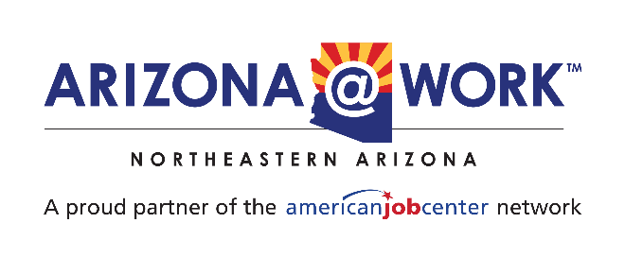
DATE June 26th, 2024
TIME 11:00 AM
LOCATION Virtual
Local Workforce Development Board
Executive Committee Meeting

 | AGENDA
WELCOME  Call to Order:  Roll call: |  |  | 5 minutes
RAPID RESPONSE REPORT  - Business service and layoff aversion activities update from Adam Garrard |  |  | 10 minutes
DIRECTOR'S REPORT  - General update on department activities  - Business services funding and hiring plans |  |  | 5 minutes
OLD BUSINESS  Data Subscription Renewal  Update on status of Lightcast, Atlas, and Transfr.  Update on Administrative Policy and Job Center Policy consulting contracts (Workforce180); (Pathway2Careers). |  |  | 10 minutes
NEW BUSINESS  Discussion: Local issues relevant to executive committee members  Committee members are encouraged to discuss trends, events, and concerns about recent development in the community to explore how we can address them as a workforce area.  Review Procedures for Upcoming Elections / Board Term-Renewal  The staff team is not proposing any new board actions at this time. |  |  | 20 minutes
CLOSING  Next meeting: August 28th 2024 at 11:00 AM  Meeting adjournment: |  | 5 minutes

