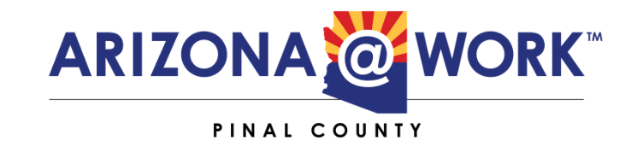

Youth Committee Meeting Minutes
DATE: Tue September 7th, 2021
TIME: 1:00pm - 2:00pm MST
LOCATION: ONLINE - Until Further Notice
REMOTE: https://us02web.zoom.us/j/88063840151?
pwd=N21OUGc0cFBOTEh3WjZPamU0N1pEdz09
Meeting ID: 880 6384 0151 Passcode: 223709

Welcome & Roll Call
Meeting called at 1:02pm
Youth Committee Members Present:
Erica Ballesteros
Cara Bryant
Raleigh Jones
Logen Kelly
Lynn Parsons
John Scrogham
Joel Villegas
Richard Wilkie
Youth Committee Members Absent:

Board Staff Present: Joel Millman, Mariah Cavazos
Review Purpose of Youth Committee
The purpose of the Youth Committee is to work with Pinal County Workforce Development Board to come up with youth focused strategies.
Review Pinal County Workforce Development Board Strategic Plan – Youth Focused Strategies
Joel Millman provided the Youth Committee with the PCWDB Strategic Plan outlining goal groups that focus on enhancing the talent pipeline of work-ready individuals and connect that diverse workforce with high quality, sustainable jobs.

Review Workforce GPS Youth Resources
US Department of Labor created the WorkforceGPS website to show others around the county what they are doing with their youth committee.
Meeting Schedule
We will meet monthly on the first Tuesday of every month at 1pm until a strategic plan is developed.
Adjourn
Meeting adjourned at 2:00pm.

