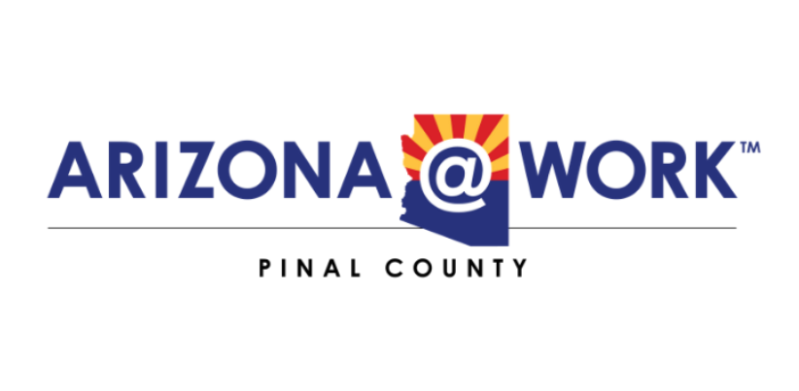
Goal Group #3 Meeting Agenda
DATE: Tue February 14, 2022
TIME: 2:00pm - 3:00pm MST
LOCATION: ONLINE - Until Further Notice
GROUPS: Goal Group #3
REMOTE: https://us02web.zoom.us/j/82551268631?pwd=Y3V1U1V5dlVrRGtxV1lSU2YyNWRGQT09
Meeting ID: 825 5126 8631
Passcode: 755307

- Welcome & Roll Call
- Approval/Disapproval of the January 10, 2022 Meeting Minutes
- Approval/Disapproval of the December 13, 2021 Meeting Minutes
- Appointment Setters Plan Presented by Aaron and Tim
- Report Out by the One Stop Operator
- Action Plan
- Next Meeting – March 14, 2022
- Adjourn

