Phoenix Business and Workforce Development Board
Advancing Youth Workforce Committee Meeting Minutes
May 26, 2020 ~8:30 a.m.

The virtual meeting of the Phoenix Business and Workforce Development Board Advancing Youth Workforce Committee was held on May 26, 2020.

Committee Members Present
Daniel Barajas (Chair)
Bethany Woodard (Vice-Chair)
Jenna Kohl
Melissa Trujillo
Nick DePorter
Charlie Boyce
Ryan Young

Committee Members Absent:
Travis Hardin
Victoria Pettit

Public Attendees:
Christina Edwards (PBWDB Liaison) Mark Carr
Elizabeth Cole Reeta Devi
Tracee Spire Dustin Panoff
Mary Alejandro Abby Garcia
Kweilin Waller Demitria Robles
Gina Harper Dustin Panoff
Silvia Valadez (AYWC Administrative Support Staff)
Action items taken are noted in bold print.

- Call to Order:
Advancing Youth Workforce Committee (AYWC) Chair, Daniel Barajas, called the May 26, 2020 meeting to order at 8:40 a.m. Roll call was completed by AYWC Administrative Support, Silvia Valadez, and a quorum of six members were present.

- Approval of AYWC April 28,2020 Meeting Minutes:
AYWC Chair Daniel Barajas suggested a motion to approve the AYWC meeting minutes. AYWC member Melissa Trujillo made a motion to approve the AYWC minutes for April 28, 2020 and AYWC member Ryan Young seconded.

Approved: Daniel Barajas, Jenna Kohl, Nick DePorter and Charlie Boyce.

Opposed: None

Motion passed unanimously

Bethany Woodard joined the meeting at 9:00 a.m.

- YMCA Service Overview:
Dustin Pannoff, YMCA Representative, talked about the services the YMCA has been offering in light of the COVID-19 pandemic. During the stay-at-home order, nine of the YMCA locations remained open to provide emergency child care for essential workers that remained in the workforce. Additionally, they continued to offer GED classes and tutoring virtually. Their Year-Up program also continued, however with a smaller cohort of about four or five youth enrolled. In order to keep everyone safe, Year-Up case managers were not allowed to meet with youth in the building so meetings took place outdoors. Since the stay-at-home order was lifted, all branches have re-opened their workout centers and the Maryvale location received permission to open 2-3 times a week. With the implementation of safe social distancing, GED classes are now taking place in the center. Additionally, all YMCA staff are required to wear masks and do a wellness check and temperature check at the beginning of their shifts. Furthermore, cleaning is done before the branches open and periodically throughout the day. Recently, several WEX participants have been hired at multiple YMCA locations to assist with front desk and welcome center work. Also, the Maryvale location has just opened up a youth run print studio, making t-shirts, vinyl prints, window decals, stickers and floor decals. The goal within the next year is to have all YMCAs in the country use this print shop for their printing needs.

- Technical Assistance Guide:
AYWC Chair Daniel Barajas invited City of Phoenix, ARIZONA@WORK, Youth Workforce Program Manager, Mark Carr to provide an overview of the Technical Assistance Guide that is currently being developed. The previously created Provider Referral Matrix will be replaced by this much more comprehensive Technical Assistance Guide. The guide’s purpose is three-fold:
- Provide guidance on the youth program requirements set forth by the Workforce Innovation and Opportunity Act, Department of Labor and ARIZONA@WORK City of Phoenix.
- Serve as a technical assistance guide as it relates to youth program operations and regulation.
- Provide resources to support youth program policy development, program design and implementation.

Some of the components the guide will include are: eligibility, intake and enrollment; employer engagement; program management; partnerships; case management; eligible training provider list; work experience training and education, participant referrals; support services; performance accountability; and participant exit and follow-up.

- Performance Metrics Updates:
AYWC Chair Daniel Barajas invited City of Phoenix, ARIZONA@WORK, Human Services Department (HSD) Deputy Director, Kweilin Waller to provide a performance metrics update.

There are five performance measurers under WIOA for adult, youth and dislocated work programs: employed second quarter, after exit (education/training/employment for youth); employed fourth quarter, after exit (education/training/employment for youth); median earnings in the second quarter, after exit; credential attainment rate and measurable skills gains (MSG). Because the AYWC has shared an interest in receiving real time measures, City of Phoenix, ARIZONA@WORK, Human Services Department (HSD) Deputy Director, Kweilin Waller shared that currently all performance metrics, except for MSG, are measured after participants have completed their plan of action and are no longer active in the program. This means that MSG is the only metric that is a real time measure.

Below are the City of Phoenix ARIZONA@WORK 2019 program goals:

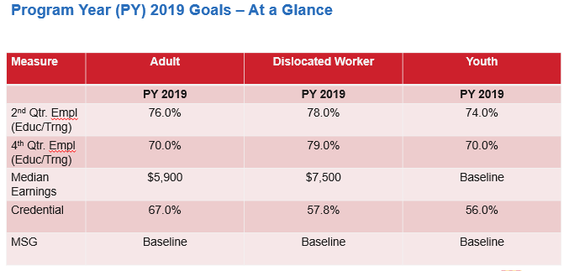
To note: The current program year is a baseline year for both median earnings and MSG.

The program is currently in the third quarter and exceeding it’s target in the first
two measures (2nd and 4th quarter education/training after exit). The third measure is a baseline (median earnings) and the credential attainment rate is below taget but
The City is working with it’s youth providers to meet this target goal.

Below are the time frames from which these measures are obtained:
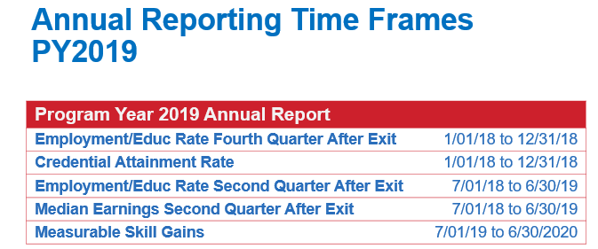

City of Phoenix staff are currently working on the new Youth Workforce Program Request for Proposal and will focus its program performance measures on:
- Determining the availability of real time measures in the Arizona Job Connection (AJS) case management system.
- Focusing on outcomes for youth.
- Identifying how many youth the program wants to serve in the City of Phoenix over the next four years.
- Measuring program effectiveness-outreach and recruitment, service delivery and employer engagement.

6. ARIZONA@WORK Youth Provider Upcoming Events and General Updates:
AYWC Chair Daniel Barajas invited the youth providers to share any upcoming events or updates.
- Gina Harper, JFCS Representative shared that in order to accommodate for the current COVID-19 pandemic, adjustments had to be made to how they provide services. These are some of the examples of the adjustments: no more than ten people are allowed in the office at one time; clients are seen through appointments only; temperature checks are made; wearing masks is required; postponing GED graduation until the fall.
- Reeta Devi, CPLC Representative shared that they are also taking all the necessary precautions, given the COVID-19 pandemic and thus, have been working from home and will continue to work from home until June 30^{th.} They have been providing services to youth virtually and in some cases in person.
- AYWC Chair Daniel Barajas shared that during the last Phoenix Business and Workforce Development Board (PBWDB) meeting, the PBWDB was contemplating whether or not to have June committee meetings. AYWC Chair Daniel Barajas invited City Staff to comment on the matter and whether there are any items that require AYWC to meet in June. Per PBWDB Liaison, Christina Edwards, the PBWDB leadership are leaving it up to the individual committees to determine if they want to meet, however there isn’t anything pending that necessitates a June AYWC meeting. She and the PBWDB Executive Director, LaSetta Hogans, will be meeting with the PBWDB Chair and Vice-chair this afternoon to discuss and set an action plan in place regarding the new structure of the committees. AYWC Chair Daniel Barajas asked if it would be helpful to meet, given the new committees’ structure changes or if that information would be provided individually. Per PBWDB Liaison, Christina Edwards, this information will be provided to each AYWC and PBWDB member individually. Once the new structure is in place, a survey will be sent out to all committee and board members to determine their area of interest. AYWC Chair Daniel Barajas requested feedback from the AYWC members on whether to meet in June. Members Melissa Trujillo, Charlie Boyce, Nick DePorter and Bethany Woodard opted to skip the June AYWC meeting meet in July, once the new committee structure and members are in place. Ad-Hoc Committee Member, Ryan Young, expressed an interest in meeting in June. Given the AYWC member’s feedback and the lack of actionable items, the AYWC decided to hold off on meeting until July.

7. Matter for Future Discussion:
- The Technical Assistance Guide will potentially be ready in July for the committee to review.
- The June AYWC meeting will be canceled.

8. Call to The Public:
None

9. Adjournment:
AYWC Chair Daniel Barajas suggested a motion to Adjourn the meeting. AYWC member Ryan Young made a motion to adjourn and AYWC member Bethany seconded.

Approved: Daniel Barajas, Jenna Kohl, Melissa Trujillo, Nick DePorter and Charlie Boyce.

Opposed: None

Motion passed unanimously

The meeting adjourned at 9:34 a.m.

