Phoenix Business and Workforce Development Board
Executive Leadership Committee Meeting Minutes
October 08, 2020 ~ 8:30 a.m.

The meeting of the Phoenix Business and Workforce Development Board Executive Leadership Committee was held virtually on October 08, 2020.

Committee Members Present:

Audrey Bohanan (Chair)
Michael Hale (Vice Chair)
Daniel Barajas
Dean Van Kirk

Erick Garcia Brandon Ramsey
Nick Bielinski Steven Cramer
Jesus Love

Committee Members Not Present:
Latasha Causey
James Frolov

Public Attendees:

Stacey Van Emst
Stan Flowers
LaSetta Hogans
Christina Edwards
Eric Johnson
Ricky Duran
Kweilin Waller
Demitria Robles

Action items taken are noted in bold print.

- Call to Order/ Roll Call/ Chair Update:
PBWDB Chair Audrey Bohanan called the October 8, 2020 Phoenix Business and Workforce Development (PBWD) Board Executive Leadership Committee (ELC) Meeting to order at 8:30 a.m. Roll call was completed, and quorum was met with nine members in attendance.

- Approval of Minutes for August 13, 2020 ELC Meeting:
ELC member Nick Bielinski made a motion to approve minutes for the August 13, 2020 ELC Meeting and ELC member Steven Cramer seconded.

Approved: Audrey Bohanan, Michael Hale, Daniel Barajas, Nick Bielinski, Steven Cramer, Erick Garcia, Jesus Love, Brandon Ramsey, and Dean Van Kirk

Opposed: None

Motion passed unanimously

- PBWD Board Staff Resource Guide:
The Staff Resource Guide shown below was shared with the ELC members. The guide identifies staff that work on behalf of the board and which departments within the City they are located. Additionally, the guide lists all of the ARIZONA@WORK City of Phoenix service locations and managers at each location, as well as the Business and Workforce Development Center staff.

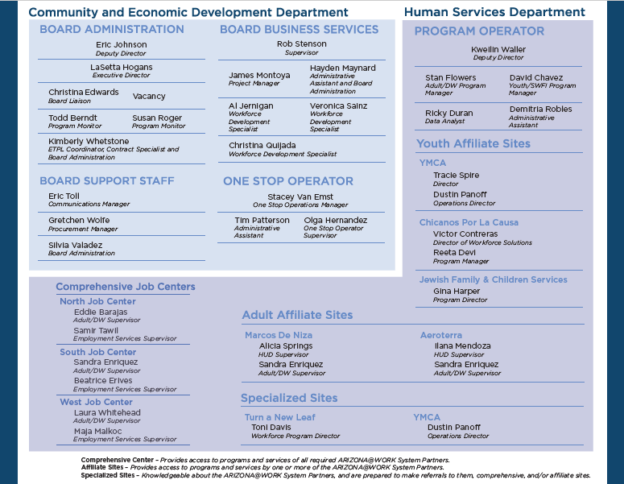

4. Client Referral System Update:
One-Stop Operator (OSO), Stacey Van Emst, gave an update on the progress of the Client Referral System (CRS). The OSO has completed the referral and response forms for all the partners who are participating the CRS pilot. A CRS user guide and video have been created and uploaded to the CRS website to assist users in navigating the system. The pilot will begin on October 19, 2020 with the following partners: City of Phoenix (Title IB), YMCA Youth (Title IB), Literacy Volunteers of Maricopa County (Title II), Rio Salado College (Title II), AZ Department of Economic Security-Employment Services (Title III) and AZ Department of Economic Security-Vocational Rehabilitation (Title IV). Feedback will be captured during the pilot and changes to the CRS will be made as needed.

The OSO, Stacey Van Emst met with Pinal and Pima County Local Workforce Development Areas on how their client referral system is working.

Stacey submitted a report detailing efforts to meet with Maricopa County Workforce Development Board’s OSO, Maximus, to discuss potential collaboration on the client referral system. It has been a challenge trying to meet with Maximus as they have cancelled meetings or not returned emails. At this time, Maximus stated they are not in a position to share information around their CRS, leaving us to move forward without their collaboration on working towards a unified CRS for Maricopa County.

ELC Member, Nick Bielinski, shared best practices for Human Resources culture and encouraged an email signature be added to the referral process.

5. PBWDB Policy Procedure Update:
PBWD Board Liaison, Christina Edwards, reviewed updates needed to the PBWDB Policy Procedure with the committee members. Updates made included removing language associated with the former Advancing Youth Workforce Committee and clarifying Policy Management language inside the PBWDB policy template.

ELC member Brandon Ramsey made a motion to approve the PBWDB Policy Procedure Updates and ELC member Nick Bielinski seconded.

Approved: Audrey Bohanan, Michael Hale, Daniel Barajas, Nick Bielinski, Steven Cramer, Erick Garcia, Jesus Love, Brandon Ramsey, and Dean Van Kirk

Opposed: None

Motion passed unanimously

6. ARIZONA@WORK City of Phoenix Draft Policy Review and Approval:
The following draft policies were reviewed by the ELC for approval to the full Board:

- 300.311 Draft Youth Incentive Policy

- 400.407 Draft Performance Measures Policy

C. 900.912 Draft Conflict of Interest & Code of Conduct Policy

A motion to approve ARIZONA@WORK City of Phoenix Policies A., B. and C. to the PBWD Board was made by ELC Member Daniel Barajas and seconded by ELC member Nick Bielinski.

Approved: Audrey Bohanan, Michael Hale, Daniel Barajas, Nick Bielinski, Steven Cramer, Erick Garcia, Jesus Love, Brandon Ramsey, and Dean Van Kirk

Opposed: None

7. One-Stop Operator Contract Performance Review:
PBWDB Executive Director, LaSetta Hogans, shared a high-level overview of the ARIZONA@WORK City of Phoenix One-Stop Operator (OSO), Goodwill of Central and Northern Arizona, contract performance as requested by the PBWD Board Chair and Vice Chair.

The OSO contract began in July of 2017 and will be coming to an end on June 30, 2021. Board staff are currently working with the procurement team in the City’s Community and Economic Development Department on the Request for Proposals (RFP) to identify the next OSO, due to be published in November of 2020.

According to 20 CFR 678.620, the Phoenix Business and Workforce Development Board is responsible for procuring an OSO to ensure WIOA Core and Required Partner services are available throughout the one-stop network.

The OSO’s role at a minimum is to coordinate the service delivery of required one-stop partners and service providers.

Local Workforce Development Boards may establish additional roles of the OSO to include:
- Coordinating service providers across the one-stop delivery system
- Being the primary provider of services within the center
- Providing some of the services within the center
- Coordinating service delivery in a multi-center area, which may include affiliated sites.

The OSO performance review includes:
- One-Stop System Coordination
- One-Stop Operator Staff
- Accessibility, Equal Opportunity and Non-Discrimination
- Meeting Attendance and Reporting Requirements

The OSO performed satisfactorily in all categories with the exception of One-Stop System Coordination. The OSO is required to have a One-Stop System Survey response of at least 90%. During the most recent monitoring the OSO scored 75% on the One-Stop System Partner Survey. A Corrective Action Plan (CAP) will be created to address the findings.

The OSO successfully performed the following functions during their contract period:

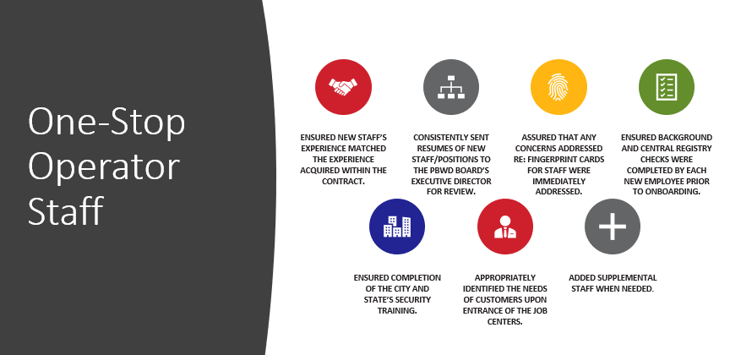

The OSO is to ensure that Equal Opportunity, ADA Signage and Accommodations are easily accessible to individuals with disabilities. Over the period of this contract the OSO has:

- Coordinated with City staff to ensure staff located in the Job Centers received accessibility training annually.
- Developed a process to ensure that updated “Equal Opportunity is the Law” notices were posted in areas for the public and staff to see.
- Supported the Board staff with the Equal Opportunity State monitoring process.
- Participated in the Job Center Certification process.

The OSO performed satisfactorily in the Meeting Attendance and Reporting Requirements category. The OSO attended Board and Committee meetings per their contract as well as when asked by Board or Board staff. Additionally, Board reports and participant surveys were noted as not being submitted timely to which the OSO implemented strategies to address this.

8. Committee Reporting to ELC & PBWDB/ Report Form:
ELC Chair, Audrey Bohanan, shared the updated draft version of the Committee Update Report and asked for feedback from the ELC members. ELC Member, Jesus Love, shared he liked the addition of committee strategies to the report form. ELC Member, Nick Bielinski, echoed Jesus’ comments and stated this was a great way to keep the committee’s accountable to their individual strategies.

Chair Bohanan reminded the ELC members that they can add the Committee Update Report as an agenda item, maybe the last item before Matters for Future Discussion, so the committee can complete the form together.

Danial Barajas shared that his committee, Program Excellence Committee, is going to look at adding the report as an actual agenda item moving forward.

9. Committee Update Reports:

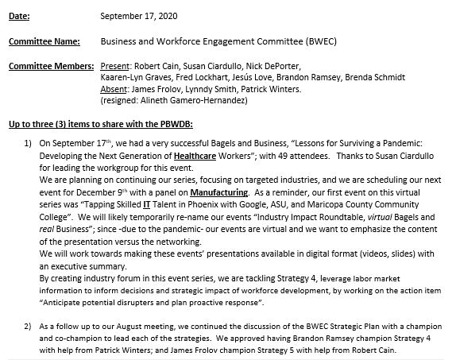
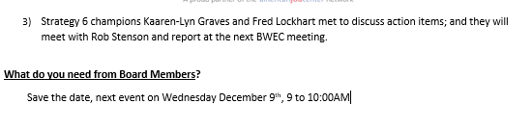

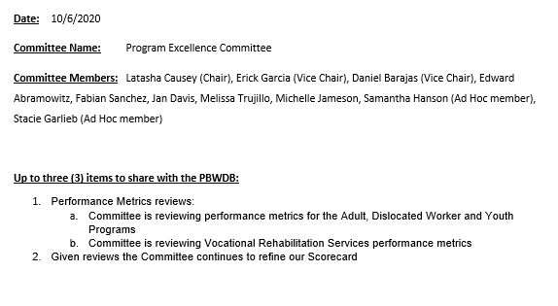

Jesus Love, BWEC Chair, shared that 49 individuals attended the last Bagels & Business event and thanked committee members and staff for their assistance in making this event a success. The committee is working on their scorecard through co-champions for each strategy. Co-champions meet outside of committee meetings and work on scorecard objectives.

10. ELC Scorecard Review and Work Plan Assignments:
ELC Chair, Audrey Bohanan, reviewed the two strategies on the ELC scorecard and opened up the conversation to the committee members as to how the work on the strategies should be completed. Executive Director, LaSetta Hogans, shared that the committee wanted to add the items from the Work Plan to the ELC scorecard so there is only one document containing ELC work priorities.

ELC Chair, Audrey Bohanan, shared that the key performance metrics under WIOA for each program, Adult, Dislocated Worker and Youth, have been shared with the Board and the Program Excellence Committee will take ownership of those measures to ensure we meet our performance standards.

Executive Director Hogans shared that items from the committees can be shared up to the ELC and/or full board. Chair Bohanan asked how can we track ROI for our programs? Executive Director Hogans shared that strategies on the scorecard are broken-out by each committee and their members through champions and co-champions. This appears to be an effective way to start the work on each individual strategy.

Chair Bohanan shared that gaps, performance misses and trends should be reported back to the full board or ELC by the committees.

Chair Bohanan asked if committee members would like to identify champions for the two strategies, Strategy 7 and Strategy 11, and asked committee members to come back to the next meeting with volunteers.

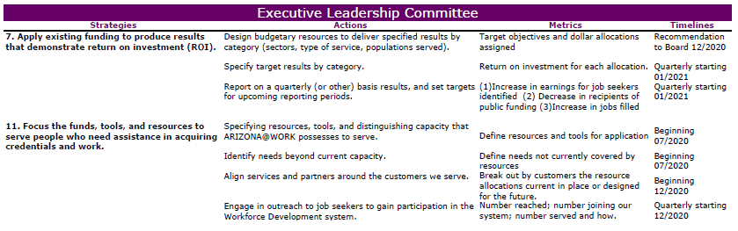

11. Matters for Future Discussion:

- ELC Scorecard Strategy #11 address with the full board
- How do we increase Board and Committee participation in the COVID environment?

12. Call to the Public and Open Discussion:

One-Stop Operator Quarterly Partner Meeting, Thursday, October 15, 2-4pm

13. Adjournment:
A motion to adjourn the meeting was made at 10:10 a.m. by ELC Member Jesus Love and seconded by ELC member Nick Bielinski.

Approved: Audrey Bohanan, Michael Hale, Daniel Barajas, Nick Bielinski, Steven Cramer, Erick Garcia, Jesus Love, Brandon Ramsey, and Dean Van Kirk

Opposed: None

All were in favor and the meeting adjourned at 10:10 a.m.

