Phoenix Business and Workforce Development Board
Executive Leadership Committee Meeting Minutes
August 13, 2020 ~ 8:30 a.m.

The meeting of the Phoenix Business and Workforce Development Board Executive Leadership Committee was held virtually on August 13, 2020.

Committee Members Present:

Audrey Bohanan (Chair)
Michael Hale (Vice Chair)
Daniel Barajas
James Frolov

Latasha Causey Brandon Ramsey
Nick Bielinski Steven Cramer
Jesus Love

Committee Members Not Present:
Erick Garcia
Dean Van Kirk

Public Attendees:

Stacey Van Emst
Stan Flowers
LaSetta Hogans
Christina Edwards
Eric Johnson
Michael Burchett
Kweilin Waller
Mark Carr

Sheila Murphy Tracey Regenold

Action items taken are noted in bold print.

- Call to Order/ Roll Call/ Chair Update:
PBWDB Chair Audrey Bohanan called the August 13, 2020 Phoenix Business and Workforce Development (PBWD) Board Executive Leadership Committee (ELC) Meeting to order at 8:30 a.m. Roll call was completed, and quorum was met with nine members in attendance.

- Approval of Minutes for June 11, 2020 ELC Meeting:
ELC member Jesus Love made a motion to approve minutes for the June 11, 2020 ELC Meeting and ELC member James Frolov seconded.

Approved: Audrey Bohanan, Michael Hale, Daniel Barajas, Nick Bielinski, Latasha Causey, Steven Cramer, James Frolov, Jesus Love and Brandon Ramsey

Opposed: None

Motion passed unanimously

- CONSENT Item for Approval:
ELC member James Frolov made a motion to approve the consent item, and ELC Vice Chair Michael Hale seconded.

Approved: Audrey Bohanan, Michael Hale, Daniel Barajas, Nick Bielinski, Latasha Causey, Steven Cramer, James Frolov, Jesus Love and Brandon Ramsey

Opposed: None

Motion passed unanimously

4. Client Referral System Update:
One-Stop Operator, Stacey Van Emst, gave an update on the progress of the Client Referral System (CRS). The OSO has been meeting with the WIOA core partners in creating the CRS. Stacey shared a high-level overview of the CRS with the committee detailing the steps in the process to refer customers to partner programs. Stacey shared her screen, showing the actual referral system, it’s functions and each partner provider’s informational page.

Stacey indicated that updates are still being made, but the completion of the framework for the referral system is priority one. Feedback from core partners continues to be a driving force in developing the CRS framework.

ELC Chair, Audrey Bohanan, wanted to know if any partners have express disinterest in participating in the referral system and when can we expect all partners to be on-board for the CRS to go live. Stacey stated she has not received any push-back from the partners but has received feedback that some partners do not see a need to make referrals. Stacey will continue to work on making the CRS easy to use in the hopes that all workforce system partners will utilize the referral system.

ELC Member, Jesus Love, thanked everyone for their work on the CRS and the committee for implementing a timeline for the completion of the referral system. Jesus verified that staff from the partner organizations are authorized to send/receive a referral and asked if there is a way to have anyone other than staff enter the CRS and send a referral. Stacey stated she would follow-up with Jesus on that question.

ELC Chair Bohanan reiterated that customers should be referred to the ARIZONA@WORK City of Phoenix locations and that she would possibly like to incorporate business cards for Board members to hand out to potential customers. Chair Bohanan added the business cards discussion should be added to the next Executive Leadership Committee agenda.

ELC Vice Chair, Michael Hale, asked Stacey what elements of the referral system she feels are most important or accurate in providing the best information possible. Stacey indicated the referral system is easy to navigate and the information is displayed in a manner that new/existing staff can easily find what they need. Technology continues to be an issue as different organizations use different technology and have firewalls in place. Stacey will continue to work with the City’s IT department to resolve those issues as they arise.

Vice Chair Hale asked Stacey what her biggest fear is in using the CRS. Stacey indicated her biggest fear is that the referral system does not get utilized. Additionally, partnering with Maricopa County may be a good idea, as using two separate referral systems would be a challenge for the partners.

Vice Chair Hale asked whether we have established metrics for the use of the CRS. Stacey shared that we don’t have benchmark data across the system because partners are not using one, single referral system. We can track referrals from Title IB to Title III, but there is no benchmark data. Stacey indicated she can contact partners to try and get baseline data if that is what the Board would like. Stacey said she will ask partners at the next quarterly partner meeting what the volume of their referrals looks like. Vice Chair Hale encouraged Stacey to gather that information to help set metrics for the use of the CRS.

5. Memorandum of Understanding (MOU) and Infrastructure Funding
Agreement (IFA) Update:
PBWDB Executive Director, LaSetta Hogans, gave an update to the committee on the MOU/IFA. The MOU is an agreement between the PBWD Board and all the WIOA required partners on the delivery of workforce services in the City of Phoenix. The IFA details how costs will be shared amongst the system and co-located partners.

On June 22, 2020, Audrey Bohanan, Christina Edwards and Executive Director Hogans met with the WIOA core and required partners and reviewed the MOU, noting suggested changes by the partners. From there, separate meetings have been scheduled with several of the MOU partners to talk about the IFA. Direction was recently received from the Arizona Department of Economic Security (ADES) stating a draft MOU/IFA must be submitted by August 31, 2020.

After the draft MOU/IFA are approved by AZDES, they will go the PBWDB for review and approval, and then to Phoenix City Council for approval.

ELC Chair Bohanan asked if LaSetta needed anything or additional Board support to complete the MOU/IFA. Executive Director Hogans stated she would welcome additional support from the Board and reference an item on the meeting’s agenda pertaining to ELC members assignments where members will have the opportunity to volunteer for projects the ELC is responsible for completing this program year.

6. PBWD Board Bylaw Amendments:
PBWD Board Liaison, Christina Edwards, presented all of the updates made to the PBWDB bylaws, including the updated Mission and Vision of the Board. The following updates were provided:

- ARTICLE IV. RESPONSIBILITIES AND METHODS, Section II. Methods was added to include the methods for performing the PBWDB functions outlined in WIOA.
- ARTICLE V. MEMBERSHIP, Section II. Nominations and Appointments. Individuals are appointed to the PBWDB by the City of Phoenix Mayor and approved by the City Council in accordance with State criteria established under WIOA Sec. 107(b)(2).
- ARTICLE V. MEMBERSHIP, Section IV. Vacancies and Resignations. To comply with Workforce Arizona Council Local Governance Policy, PBWDB vacancies must be filled within 120 days of the vacancy.
- ARTICLE V. MEMBERSHIP, Section V. Attendance was changed to reflect that any three absences from a regularly scheduled board meeting, during a program year (June 30-July1), will result in a recommendation to the City of Phoenix Mayor for removal from the PBWDB.
- Adding new officer designations and Chair and Vice Chair roles to ARTICLE VI. ELECTION OF OFFICERS, Section I. and Section III.
- Adding additional responsibilities to the Executive Leadership Committee under ARTICLE VII. COMMITTEES, Section II. Executive Leadership Committee.
- ARTICLE VII. COMMITTEES, Section IV. Other Committees added subsection D. Workgroups.
- Added ARTICLES IX. ETHICS AND CONFLICT OF INTEREST, X. CONFLICT RESOLUTION, XI. AMENDMENTS and XII. SEVERABILITY

Board Liaison Edwards explained that the bylaw amendments will go the Phoenix City Council for approval at the end of August.

A motion to approve the amendments to the PBWD Board Bylaws was made by ELC Member Steven Cramer and seconded by ELC member Daniel Barajas.

Approved: Audrey Bohanan, Michael Hale, Daniel Barajas, Nick Bielinski, Latasha Causey, Steven Cramer, James Frolov, Jesus Love and Brandon Ramsey

Opposed: None

7. Committee Update Reports:

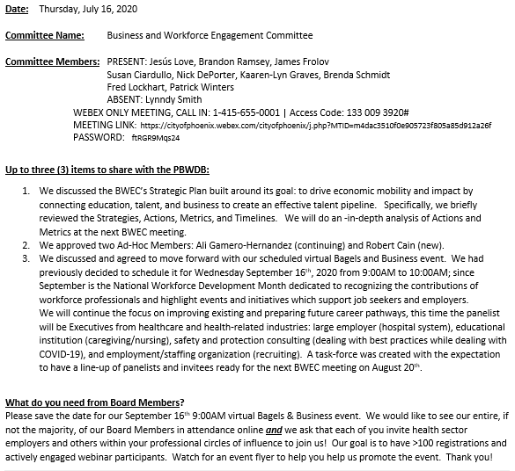

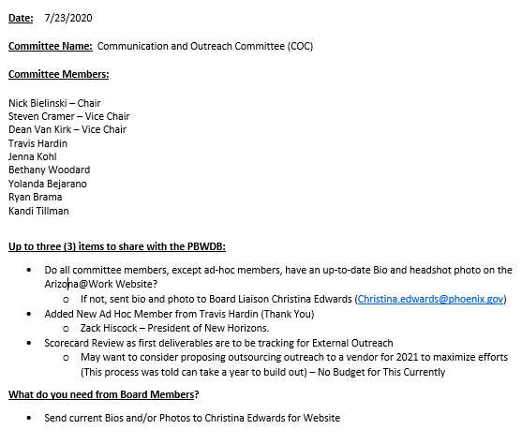

8. Committee Leadership – Roles and Responsibilities:
ELC Vice Chair, Michael Hale, thanked the committee for being leaders of their respective committees and for their participation in the strategic planning process. Vice Chair Hale wants to empower the committee leaders and provide suggestions on how to manage the two Vice Chair roles.

The second Vice Chair position was created within the committee structure to develop a deeper bench and allow the committee to be agile. A second committee Vice Chair also provides active exposure and development of an additional Board member as they gain experience in leadership and growth within the organization. The committee Vice Chairs can partner with the Chair and take-on some of the duties of the committee. And finally, the second Vice Chair allows for constancy within the committee as either Vice Chair can lead the committee in the Chair’s absence.

Some things to consider around the new Vice Chair role: designate who the subject matter expert will be, have Vice Chair’s lead specific goals, provide a monthly report to the Board with the Vice Chair input prior to submitting the final copy to the PBWDB, play to each Chair and Vice Chair’s strengths. PBWDB leadership wants Chairs and Vice Chairs of the committees to engage with each committee member, identify each member’s strength, then play to those strengths.

Vice Chair Hale asked that once each committee has decided what the roles of the Chair and Vice Chairs will be to please send that information over to Vice Chair Hale and Chair Bohanan so that they know what the plan is for each committee. Additionally, once the configuration between the three leaders has been identified, share that information with the committee members so a plan to do the work of the committee can be developed.

Vice Chair Hale encouraged Chairs/Vice Chairs not to dominate conversations and to allow their committee members to engage during the meeting. PBWDB leadership wants to ensure barriers are removed so the committee can perform their duties and asked what they can do to help. Vice Chair Hale indicated he and Chair Bohanan will attend as many committee meetings as they can and made sure the Chairs are comfortable with that.

ELC Member, Nick Bielinski, shared that in-person meetings would be beneficial for connecting with each other and encouraged thought around how to make in-person meetings possible. Vice Chair Hale agreed that a modified version of the in-person meetings would be ideal.

ELC Member, Jesus Love, volunteered space at Literacy Volunteers of Maricopa County for in-person future meetings.

9. ELC Scorecard Review:
ELC Chair, Audrey Bohanan, reviewed the scorecard items listed below with the committee. Ensuring return on investment (ROI) is a priority for the ELC. Chair Bohanan asked for recommendations or suggestions around Strategy 7.

Dr. Sheila Murphy was on the ELC call and shared that she felt the ELC and Board are well-positioned to carry-out the work of the Board. Shaping the work of the implantation plan moving forward by strengthening the bench is a very good idea. Dr. Murphy congratulated the Board for the great work developing the Strategic Plan and scorecards. As the environment changes around us, the actions and timelines on the scorecards can change as needed. Each committee is the conduit of the full Board to lead and manage the implementation of the Strategic Plan.

Chair Bohanan indicated that we will need identify who, within the ELC, will drive certain actions on the scorecard. Chair Bohanan asked ELC members to review the scorecard and stated at the next ELC meeting we will review each action/timeline and create a plan for completion.

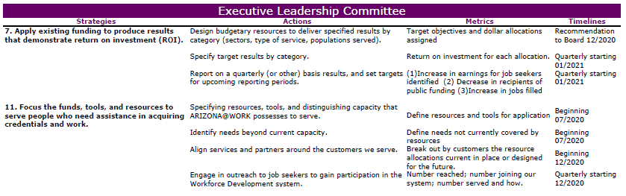

10. PBWDB Work Plan Assignments:
PBWDB Executive Director, LaSetta Hogans, reviewed the items on the workplan in detail with the ELC members. Specific ELC members were assigned workplan items and will be included in the work to complete the specific item.

11. Matters for Future Discussion:

- ARIZONA@WORK City of Phoenix Business Cards for Board members
- Review each Strategy and Action on the ELC scorecard
- Add strategies to Committee Update Report
- BoardBookIt effective usage
- COVID-19/Unemployment Insurance- How are the gig economy workers being impacted
- How can the ELC help staff, City and service providers during this health pandemic

12. Call to the Public and Open Discussion:
None

13. Adjournment:
A motion to adjourn the meeting was made at 10:32 a.m. by ELC Member Latasha Causey and seconded by ELC member Jesus Love.

Approved: Audrey Bohanan, Michael Hale, Daniel Barajas, Nick Bielinski, Latasha Causey, Steven Cramer, James Frolov, Jesus Love and Brandon Ramsey

Opposed: None

All were in favor and the meeting adjourned at 10:32 a.m.

